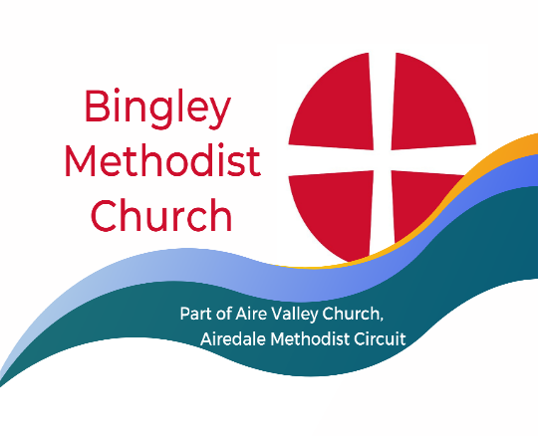

Minister Rev. Nel Shallow. Tel.01274 568163
Nel.shallow@airedalemethodists.org
Sunday 10 December 2023
Holy Communion Service led by Rev. Roger Fox
You are very welcome at our church today. We sincerely hope you receive a blessing from this service. If you would like a visit from our Minister, or if our Church Stewards can help in any way, please let us know. Please join us for coffee afterwards.

Thought for the Week- May you know God’s peace covering you His hope inspiring you.
Christmas Cards. As usual, please feel free to send one card to everyone at church. Donations are very welcome to Action for Children. There is a box for this in the dining area.

Messy Church will take place this Tuesday 12 December 3-45 to 5-30pm. This is informal and everyone is welcome, irrespective of age. Children to be accompanied by an adult please.

Christmas Services- Next week is our Carol Service
Monday 18 December at 6PM Carols in the Barn, Crag House Farm, BD20 0NP
Saturday 23 December at 10-15 Carols and Coffee at Cullingworth Methodist Church
Saturday 23 December 3 – 5pm The Nativity Forest at The Eldwick Church
Sunday 24 December AVC service at Cullingworth.

If you need help to attend Aire Valley Church services or events and you can’t get a lift, please consider using a taxi. You can either arrange one yourself, keep the receipt and give it to one of the stewards who will claim the cost back for you. Alternatively, call Esther on 07904 883288 and she will arrange one for you at no cost to yourself. Please give Esther a week’s notice though as she works part-time.
Sunday December 17
Carol Service led by Rev. Nel Shallow
Stewards Bryn and Rosalie
Door Janet C and Mike
Coffee Lindsay and Lindsey
Flowers Joyce D

TODAY
Holy Communion Service led by Rev. Roger Fox
Stewards David S and David V
Door Carol and Ian
Coffee Rosalie and Joyce H
Flowers Maureen

Items for the next notices to Lindsey Butler by Thursday please: linzibee103@gmail.com 07712 285456

