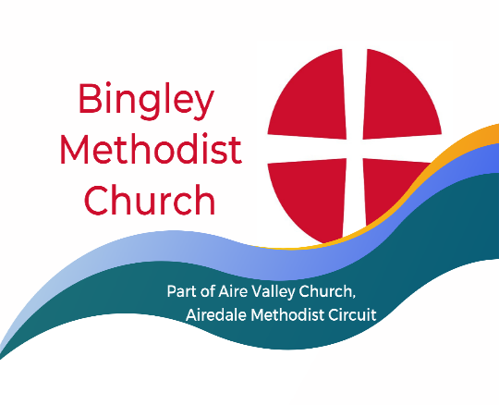

Minister Rev. Nel Shallow. Tel.01274 568163
Nel.shallow@airedalemethodists.org
Sunday 12 November 2023
Remembrance Service led by
Rev. Nel Shallow
You are very welcome at our church today. We sincerely hope you receive a blessing from this service. If you would like a visit from our Minister, or if our Church Stewards can help in any way, please let us know. Please join us for coffee afterwards.

Bible in Ten - the group has now considered and discussed the first twenty six books (of the sixty six books) of the Bible, as reviewed in this publication which seeks to prove that the Bible is anything but dull! We meet most Mondays in Room2 of this church at 2.00pm. We will be glad to welcome anyone who would like to join these informal sessions. Further details from Ian.

As you know, it will be our Christmas Fair on Saturday 18 November- NEXT SATURDAY. There are further details and requests for help on a separate sheet. If you have not been given one, please ask Ann.
Update- The final sum raised at our recent coffee morning in aid of disasters in Libya and Morocco is now £223. Many thanks to all who contributed in any way.
There was a notice from Mike on last week’s notice sheet. This is now on the notice board for anyone who missed it. Thank you, Mike for giving us an insight into how our donations were spent to support local people with Parkinson’s. Thanks also to all who have generously donated to this cause.

Sunday 19 November
Service led by Mr Michael Webster
Stewards David S and David V
Door – Rosalie and Rachael
Coffee Catharine and Shirley
Flowers Joyce ?

TODAY
Remembrance Sunday service led by Rev. Nel Shallow
Stewards- Bryn and Rosalie
Door -Maureen and Bob
Coffee- Carol and Ian
Flowers -Muriel

Items for the next notices to Lindsey Butler by Thursday please: linzibee103@gmail.com 07712 285456

